# Sequence model

Group wants to make coffee

V

Goes in the kitchen

V

Walks to the coffee machine

V

Clean the coffee machine by throwing away the old coffee and filter

V

Takes a new filter from a drawer

V

Puts filter in the funnel

V

Take coffee box from bottom drawer

V

Put coffee in the filter

V

Put the funnel back in the machine

V

Set the amount of water using the arrows

V

Press “start”

# Notes

They normally make normal pot of coffee which requires 1.5 spoon of grounded coffee, in this instance they make only half a pot, that requires half the amount of coffee and water. They normally make 12 cups of coffee.

The trash bin is under the sink.

The filters are in the bottom drawer.

The coffee box is in the bottom drawer and the spoon is inside the box. If the box is empty there are more bags in the drawer.

The machine gets water automatically.

# Artefact model

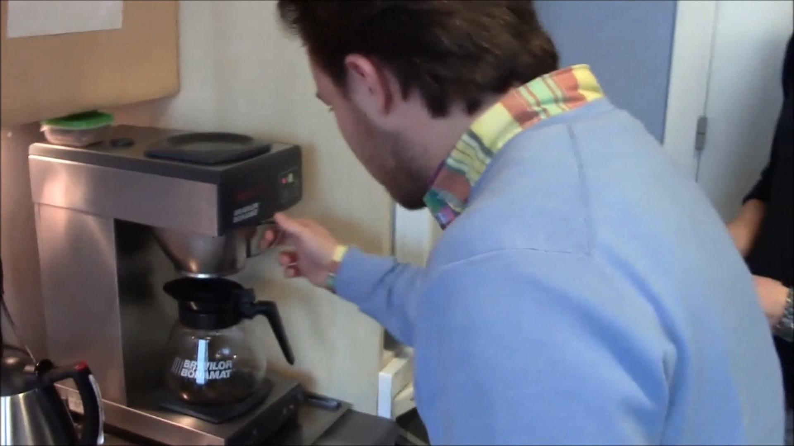

Figure 1:Taking out the old filter and coffee from the machine

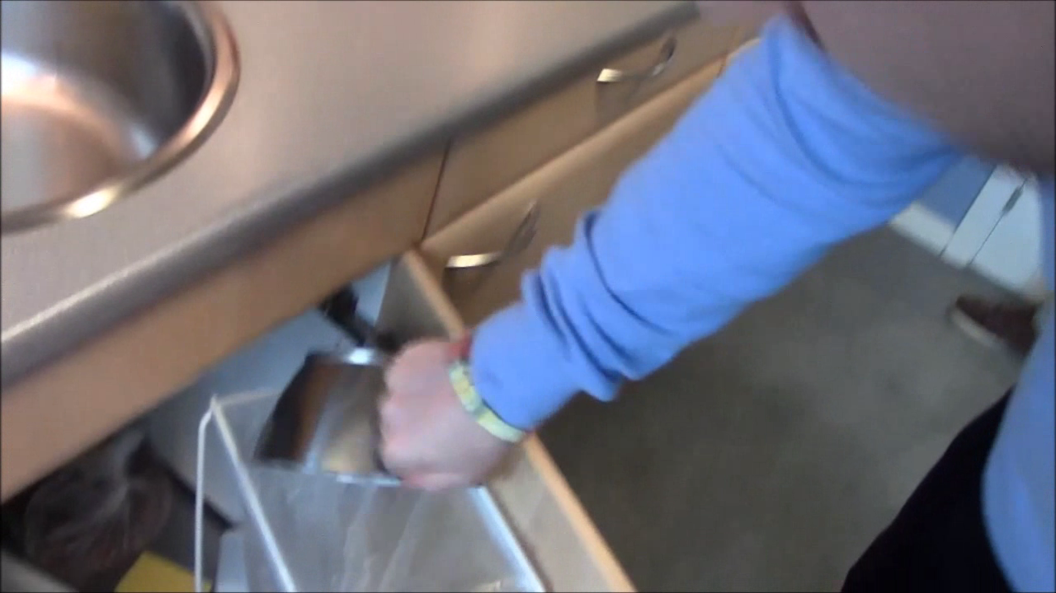

Figure 2:Throw the old coffee and filter in the trash bin under the sink

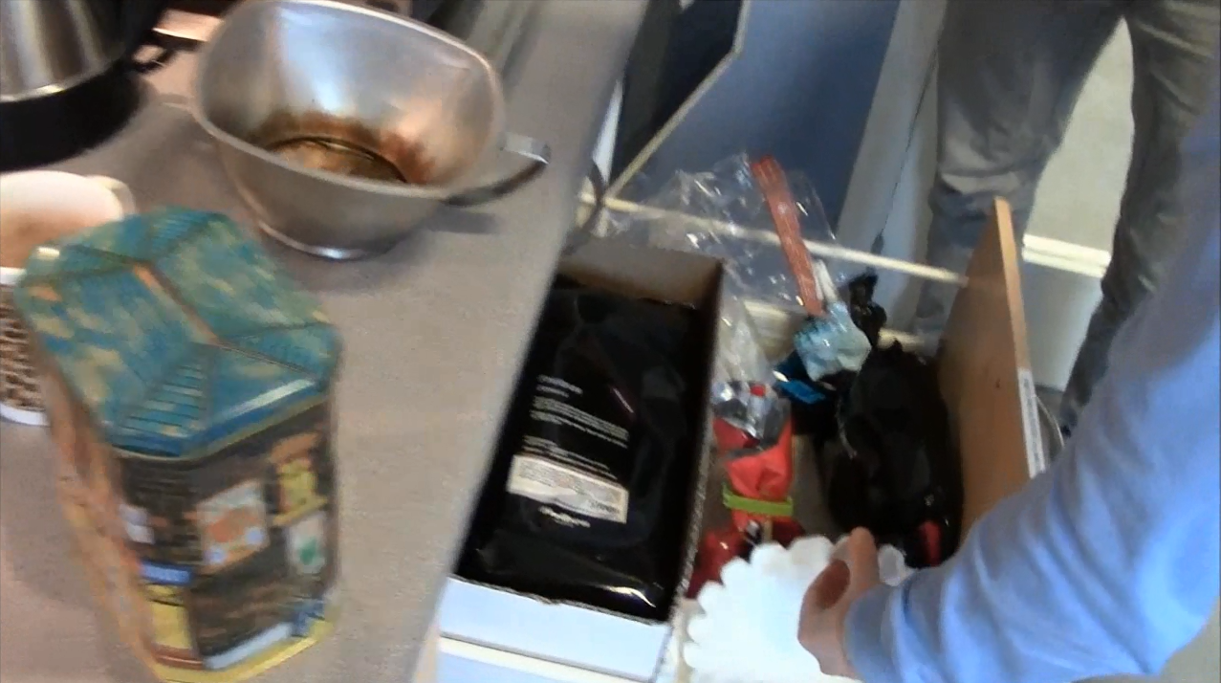

Figure 3:Takeing out the coffee box and filters from the drawer.

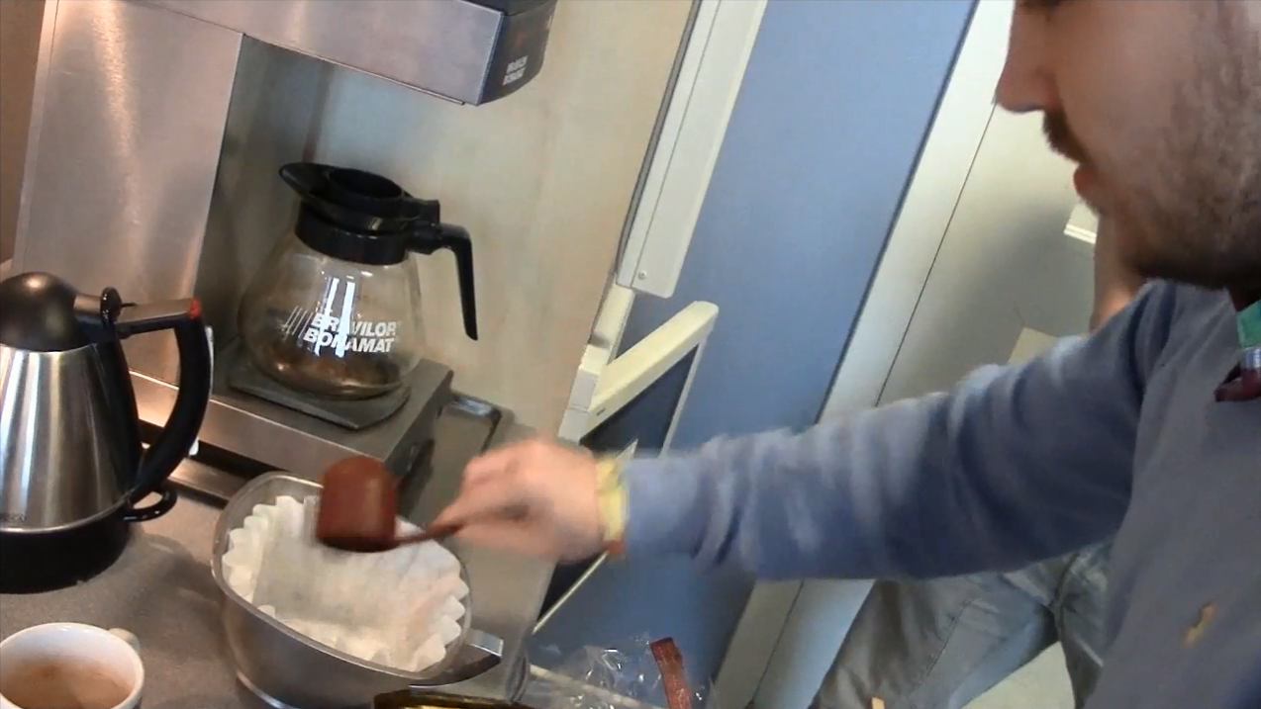

Figure 4: Using a spoon to put coffee in the machine.

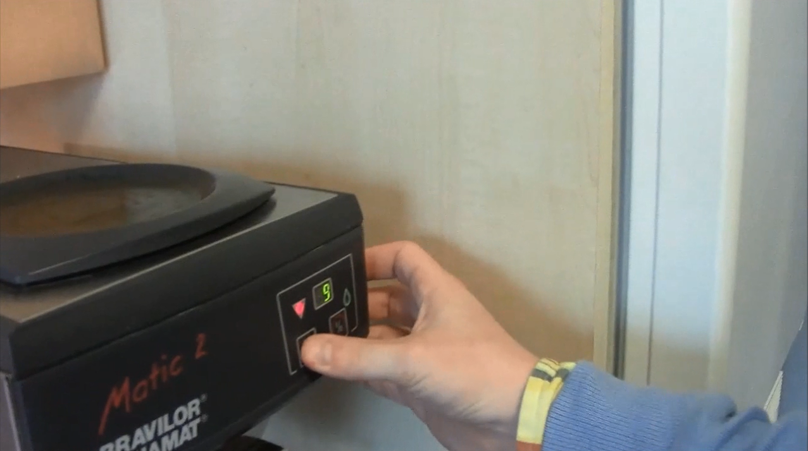

Figure 5: Selecting the number of cups of coffee to be brewed.